DEPI FINAL PROJECT REPORT
SUPERVISED by ENG.AMR SULIMAN



Team 292:
سعيد محمد سعيد
جاسر أشرف
أحمد ممدوح خالد
عمر محمد عبد الحافظ
محمد صلاح الدين
يوسف محمد مرزوق

Introduction

1.1 Overview
The Alex Agency Analytics Power BI project is designed to deliver a comprehensive, data-driven view of the company’s B2B sales and distribution performance. Using a unified and scalable analytical model, the project aims to transform raw transactional data into actionable insights that support strategic and operational decision-making across multiple business domains.
As modern organizations increasingly rely on data to optimize processes and remain competitive, this project provides a centralized analytical hub that integrates sales, customers, products, employees, territories, and shipping data into an intuitive and interactive dashboard experience.

1.2 Purpose of the Project
The main purpose of this Power BI project is to create a robust analytics solution that enables stakeholders to:
- Monitor sales performance and identify trends over time.
- Understand customer behavior.
- Evaluate product performance and highlight high- and low-performing.
- Assess employee productivity and contribution to revenue.
- Analyze geographical distribution of sales to identify regional opportunities or gaps.
- Measure shipping efficiency and delivery effectiveness.
- Provide leadership with a high-level deep-dive analytical tool for strategic planning.
This project bridges the gap between operational data sources and strategic insight generation, allowing decision-makers to act quickly and confidently.

1.3 Project Scope
The scope of the Power BI model includes:
- Integration of raw order transactions and related dimensions into a unified analytical model.
- Application of cleaning, transformation steps to prepare the data.
- Construction of a Star Schema optimized for analytical workloads.
- Development of seven main dashboard pages:
Sales Trends Analysis, Customer Insights, Product Performance, Shipping & Delivery, Geographical Analysis, Employee Performance, Deep Dive Analysis.
- Implementation of dynamic filters, and KPIs.
- Delivery of a visually intuitive interface designed for both high-level overview and deep-level exploration.

1.4 Business Value
By implementing this solution, the company benefits from:
- Faster, more reliable reporting cycles
- Better identification of business opportunities and risks
- Increased visibility into operational efficiency
- Higher accuracy in sales forecasting and resource planning
- Enhanced decision quality across departments
Ultimately, the dashboard supports data-driven culture and empowers stakeholders to make informed, timely decisions.

Data Preprocessing & Cleaning
Before developing the analytical model and dashboards, extensive preprocessing and data cleaning steps were performed to ensure data quality, consistency, and integrity. The goal was to produce a dataset that is trustworthy, performant, and suitable for analytical workloads.
Below is an outline of preprocessing steps applied during the project.

2.1 Data Ingestion
Multiple datasets were imported, typically including:
- Fact table containing order transactions
- Dimension tables for Customers, Products, Employees, Territories, Shippers, and Dates
- Data has approximately 1000 row

2.2 Data Quality Assessment
An initial assessment was performed to detect:
- Missing values
- Duplicates
- Inconsistent formatting
- Incorrect data types (e.g., dates stored as text)
- Outliers or abnormal entries
- Referential integrity issues across dimension keys
This assessment guided the subsequent cleaning steps.

2.3 Data Cleaning Steps

1. Handling Missing Values
- Null values in categorical fields (e.g., product category, customer segment) were replaced using appropriate business rules.
- Rows with extremely incomplete data were flagged and excluded.

2. Removing Duplicates
- Duplicate customer and order records were identified and removed.

3. Standardizing Data Types
All columns were converted to their correct data types:
- Dates → Date hierarchy
- Numeric fields → Decimal number
- IDs → Text

4. Fixing Inconsistent Formatting
- Standardization of customer names, product categories, and regions.
- Unifying date formats (DD/MM/YYYY or YYYY/MM/DD).
- Normalizing currency fields where applicable.

5. Creating Calculated Columns :
Some fields were constructed to support analysis, such as:
- Full customer name
- Profit margin (Profit = Revenue – Cost)
- Order year, quarter, month
- Product grouping or hierarchy fields

6. Ensuring Referential Integrity
- All foreign keys in the Fact table were validated against dimension tables.
- Missing relationships were resolved by correcting key mismatches or completing dimension records.
- Merge between tables wich has no direct key in Fact Table( to get keys to make schema)

2.4 Data Transformation for Analytics
Additional transformations were performed to optimize the model:
- Fact table was refined to remove unnecessary fields and reduce storage.
- Dimension tables were cleaned, deduplicated.
- A proper Date dimension was generated to support time intelligence DAX measures.

2.5 Final Validation
Before modeling, the cleaned dataset was validated by:
- Checking row counts across all tables
- Verifying completeness of relationships
- Reviewing summary statistics to ensure logical value ranges
- Testing a few sample measures to confirm correctness
Data Modeling & Star Schema Architecture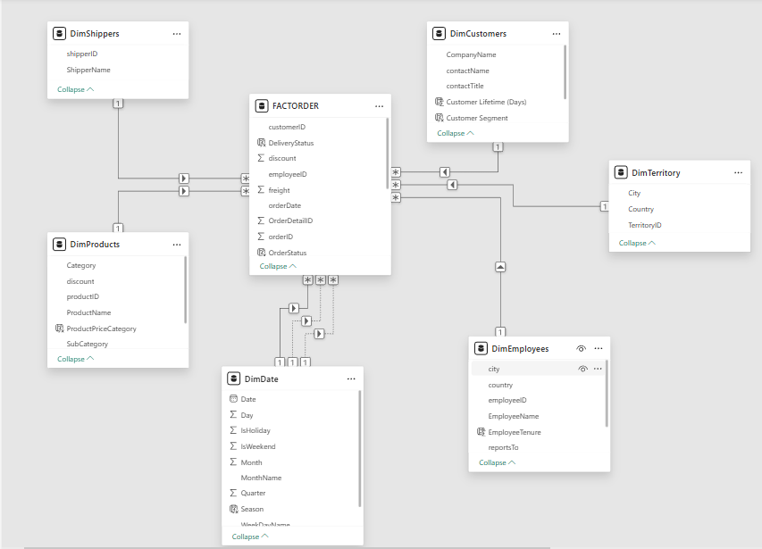

3.1 Overview of the Data Model
The analytical model for the Alex Agency Analytics project follows a Star Schema architecture, a widely adopted modeling approach for business intelligence systems.
This design provides optimal performance for aggregations, simplifies DAX calculations, and supports intuitive data exploration by end-users.
At the core of the model is the FACTORDER table, which captures essential sales transaction data. Surrounding the fact table are multiple dimension tables that provide descriptive, non-transactional context about customers, products, employees, shippers, territories, and dates.
This structure ensures a clean separation between quantitative metrics (fact table) and descriptive attributes (dimension tables), enabling fast and scalable reporting.

3.2 Star Schema Structure
model includes 1 Fact Table and 6 Dimension Tables:

🔹 FACT Table
- FACTORDER

🔹 Dimension Tables
- DimCustomers
- DimProducts
- DimEmployees
- DimShippers
- DimTerritory
- DimDate

3.3 FACT Table: FACTORDER
The FACTORDER table is the central component of the model, containing all granular transaction-level data related to customer orders.

Key Columns Identified:
- orderID
- OrderDetailID
- customerID
- employeeID
- productID
- shipperID
- orderDate
- requiredDate
- shippedDate
- quantity
- unitPrice
- TotalOrderValue
- Total Orders
- freight
- discount
- OrderStatus
- DeliveryStatus

Role of the FACT Table
The fact table stores:
- Transaction values
- Order quantities
- Pricing and discount info
- Order fulfillment details
- Keys linking to each dimension
It is the primary source of KPIs such as:
- Total Sales
- Sales by Customer
- Sales by Product
- Shipping efficiency
- Employee productivity

3.4 Dimension Tables
Dimension tables enrich the fact table by providing business context and allow slicing the data from multiple perspectives.

### 3.4.1 DimCustomers
Key Columns:
- customerID
- CompanyName
- contactName
- contactTitle
- Customer Lifetime (Days)
- Customer Segment
- TerritoryID
Purpose:
This dimension allows analyzing:
- Sales by customer segment
- Customer retention (via lifetime days)
- Behavior of different customer groups
- Regional/territorial variations in customer patterns
The presence of Customer Segment and Customer Lifetime enables deeper customer profiling and segmentation analytics.

3.4.2 DimProducts
Key Columns:
- productID
- ProductName
- Category
- SubCategory
- ProductPriceCategory
- unitPrice
- discount
Purpose:
This dimension supports:
- Product performance analysis
- Category-level comparisons
- Profitability and pricing segmentation
- Identification of best- and worst-selling products

3.4.3 DimEmployees
Key Columns:
- employeeID
- EmployeeName
- EmployeeTenure
- city
- country
- title
Purpose:
This table allows:
- Assessing employee performance
- Analyzing sales per employee
- Mapping sales performance to employee experience (tenure)

3.4.4 DimShippers
Key Columns:
- shipperID
- ShipperName
Purpose:
This dimension supports:
- Shipping performance analysis
- Carrier comparison
- Delivery time and order fulfillment studies
It gives structure to delivery-related KPIs and logistics optimization.

3.4.5 DimTerritory
Key Columns:
- TerritoryID
- Country
- City
Purpose:
DimTerritory enables:
- Regional sales analysis
- Cross-region performance comparisons
- Mapping customers geographically
Territory-focused insights support expansion strategy and localization decisions.

3.4.6 DimDate
A fully developed date dimension — essential for time intelligence.
Key Columns:
- Date
- Day
- Month / MonthName
- Quarter
- Year
- Season
Purpose:
Supports:
- YOY, QOQ, MOM trend analysis
- Time-based KPIs
- Sales seasonality detection
- Workday vs weekend patterns
This dimension is critical for all time intelligence DAX functions.

3.5 Relationship Architecture
The relationships form a clean, well-structured star schema:
The schema uses:
- Single-direction filters for performance
- Explicit date table for accurate time intelligence
The structure is optimized for:
- Fast filtering
- Smooth drill-down operations
- Accurate aggregation
- Minimal ambiguity

3.6 Advantages of This Star Schema Model

High Performance
Fact table is clean and numeric; dimensions are descriptive.
This makes the model efficient even with large datasets.

Flexibility in Analysis
Users can explore data by:
- Customer
- Product
- Employee
- Time
- Region
- Shipper
All from a single dataset.

Clear Business Logic Layer
Dimensions represent real business entities, ensuring alignment with business users’ mental models.

Scalable for Future Expansion
Additional dimensions (e.g., Promotions, Returns, Profitability) can be added without restructuring the core model.

3.7 Summary of the Data Model
schema successfully delivers:
- A centralized, clean FACTORDER table containing all transaction data
- Well-designed dimension tables that enrich analysis
- Logical, efficient relationships that enable accurate time, geography, product, and customer intelligence
- A true Star Schema optimized for analytics and reporting

Power BI Measures

1. Time Measures
These measures are related to the time aspects of your data.
- Avg Delivery Delay: Measures the average delay in delivery across orders.
- BestMonthText: Displays the best-performing month in terms of sales or another metric.
- Monthly Sales Growth %: Calculates the percentage growth in sales on a monthly basis.
- Monthly Seasonality Index: Shows the seasonality trend of sales across different months.
Ex. 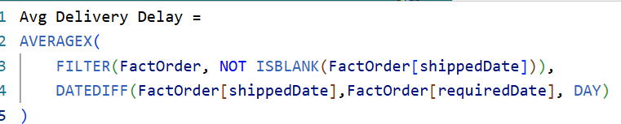

2. Products Measures
These measures are tied to the performance and sales of products.
- Avg Sales Per Product: The average sales value generated by each product.
- Category Sales: Total sales within each product category.
- Products Sold Count: The count of products sold within the dataset.
- Subcategory Performance: A measure of how each product subcategory performs.
Ex. 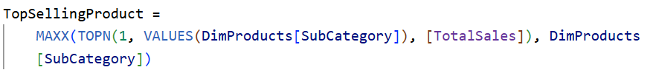

4. Sales Measures
These are essential for tracking the sales-related performance.
- Average Order Value: The average value of orders placed.
- Net Sales: Total sales after discounts and returns.
- Sales Per Employee: Measures sales performance per employee.
- Total Quantity Sold: Total units sold across all transactions.
Ex.

5. Customers Measures
Focuses on customer-related performance.
- Avg Orders per Customer: The average number of orders placed by each customer.
- Avg Sales per Customer: The average sales generated per customer.
- Customer Retention Rate: Measures how well the business retains its customers.
Ex. 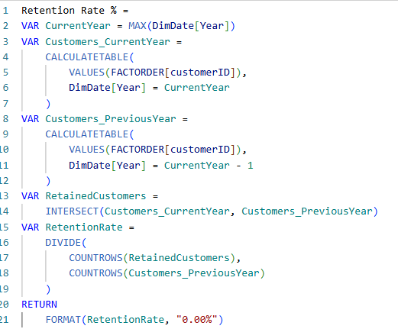

6. Performance Measures
These measures provide insights into the operational performance of the business.
- Average Delivery Time: The average time taken to deliver orders.
- Freight Cost Percentage: The percentage of sales attributed to freight costs.
- On-Time Delivery Rate: The percentage of deliveries made on time.
Ex. 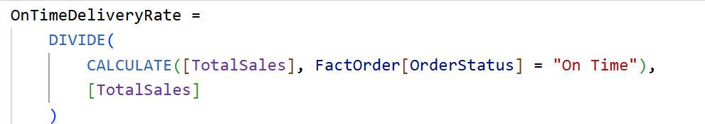

7. Geographical Measures
Focuses on performance across different geographical areas.
- Average Order Value by City: The average order value broken down by city.
- International Sales Percentage: The percentage of total sales coming from international markets.
- Sales by Country: Sales breakdown by country.
- Top Performing City: The city with the highest sales performance.
Ex. 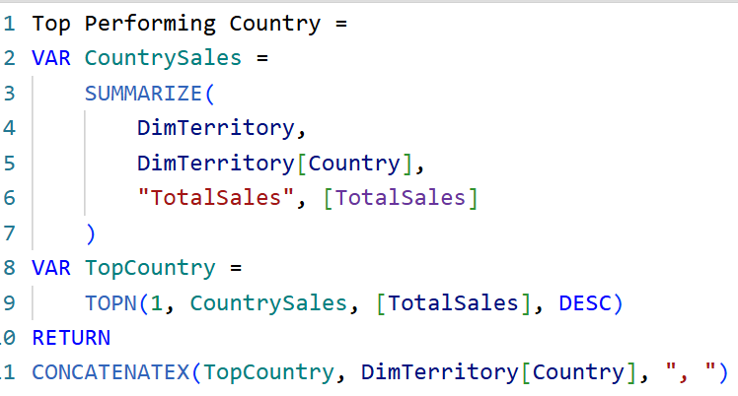

8. Employees Measures
These measures track the performance of employees.
- Avg Sales KPI Value: The average KPI value for employee sales performance.
- Employee Performance: A measure evaluating individual employee performance..
- Top Performer Contribution: Contribution of top-performing employees to the overall results.
Ex. 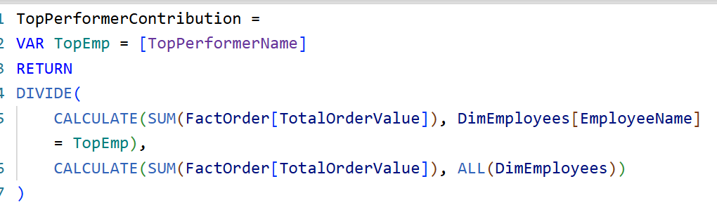

9. Shipping Measures
These focus on shipping performance metrics.
- Average Delivery Days: The average number of days taken for shipping.
- Number of Orders: The total number of orders processed.
Ex. 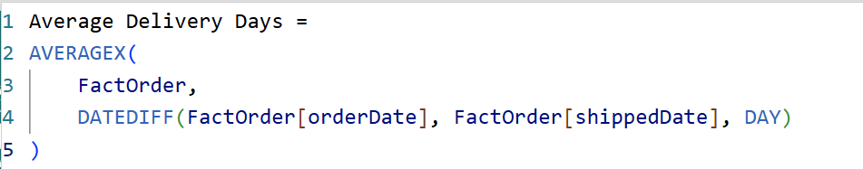

LETS GO INTO OUR REPORT :
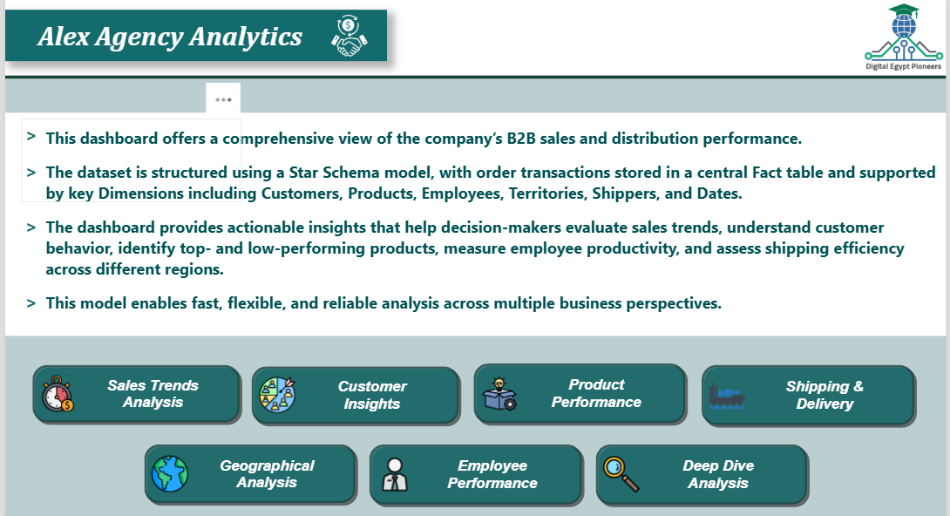

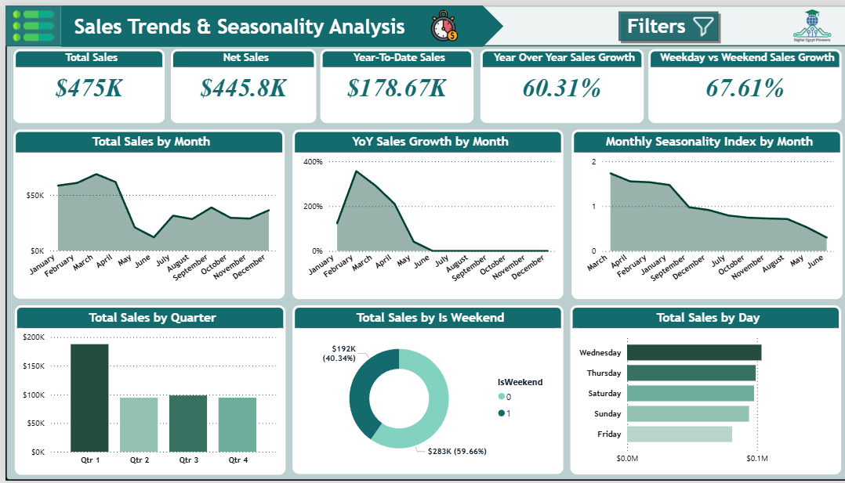

1. Total Sales Overview
- Total Sales: $475K
- Net Sales: $445.8K
- Year-to-Date Sales: $178.67K
  - Year-to-date sales for the current year are $178.67K, which can be compared with historical performance to track progress toward the annual goal.
- Year Over Year (YoY) Sales Growth: 60.31%
  - The business has seen a strong growth in sales compared to the same period last year, with over a 60% increase. This suggests robust business performance.
- Weekday vs Weekend Sales Growth: 67.61%
  - The sales growth for weekends is higher than weekdays, which may imply that weekend promotions or customer behavior heavily influence weekend sales.

2. Sales Trends by Month
- Total Sales by Month (Line Chart)
  - Strongest Months: March and February show a higher sales trend, with February having a peak in sales.
  - Weakest Months: June and May reflect the lowest sales, signaling potential seasonality factors or changes in customer demand.
- YoY Sales Growth by Month
  - Highest Growth: March shows the highest YoY sales growth (~400%), which could be a result of successful promotions or an increase in demand.
  - Slower Growth: The months of May to December reflect less YoY growth, which could signal potential market saturation or the end of a promotional cycle.
- Monthly Seasonality Index
  - The Seasonality Index graph indicates that March and February are the most seasonal months, with the highest sales spikes, suggesting that these months have strong customer demand.
  - The sales dip in May and June indicates a potential low-demand period, possibly due to seasonal factors, holidays, or external market conditions.

3.Total Sales by Quarter
- Q1 has the highest sales, reaching just under $200K.
- Q2 drops significantly to around $90K–$100K.
- Q3 shows a slight increase compared to Q2, approximately $100K.
- Q4 is similar to Q3 and Q2, roughly $90K–$100K.

Key Insight
Sales start very strong in Q1, then decline sharply in Q2, and remain relatively steady through Q3 and Q4 but never return to Q1 levels.

4. Weekend vs Weekday Sales

Weekend Sales: $192K (40.34%)
- Weekend sales account for 40.34% of total revenue.
- This indicates that sales activity is lower on weekends, suggesting fewer customers or smaller average purchases compared to weekdays.

Weekday Sales: $283K (59.66%)
- Weekday sales contribute the majority share at 59.66%.
- This shows that customers are more active—or make larger purchases—during the week.
- Opportunities may still exist to further strengthen weekday performance or use weekend-specific campaigns to rebalance traffic.

5. Sales by Day of the Week
- Wednesday and Thursday are the highest performing days, contributing significantly to sales.
  - Wednesday sees the highest sales, which might indicate mid-week promotions or specific customer behaviors.
  - Thursday follows closely, and these two days might be pivotal for week-long sales strategies.
- Sunday and Friday show slightly lower sales, but they still contribute meaningfully to the total, with Sunday trailing behind Friday.

Key Insights & Recommendations
- High Sales Growth in March and February:
  - There is a strong seasonal peak in March and February, with high sales growth in these months. Consider capitalizing on this trend by offering early-year promotions or incentives during this period to maximize sales further.
- Low Sales in May and June:
  - The months of May and June show a significant drop in sales. Consider launching targeted marketing campaigns to boost sales during this period. Investigate whether it's due to external factors like weather, holidays, or market conditions.
- Weekday Sales Performance:
  - Since weekends show stronger performance, develop strategies to boost sales even further during these times. Special weekend promotions, targeted discounts, or loyalty programs could help capitalize on the existing trend.
- Invest in Weekend Growth:
  - Weekdays contribute to a smaller portion of total sales. There is an opportunity here to increase weekday sales through promotions or special offers to increase traffic and sales during slower times.
- Focus on Wednesday and Thursday:
  - Since Wednesday and Thursday are the best performing days, special mid-week promotions or discounts could attract even more customers. Consider launching exclusive "Midweek Deals" to drive more traffic to the store/website.
- Q2 Performance:
  - Q2 shows a decline in sales compared to Q1. Investigate why Q2 underperformed and look for opportunities to adjust marketing campaigns or product offerings for Q2.
- Leverage Seasonality Insights:
  - The Monthly Seasonality Index suggests that some months experience more significant fluctuations in sales. Use this data to forecast demand more accurately and align inventory, staff, and promotional efforts accordingly.
- Customer Segmentation and Behavior Insights:
  - Based on the data, With deeper analysis into customer segments (e.g., weekday shoppers vs weekend shoppers) to tailor offers and promotions.
- Year-Over-Year Growth:
  - A 60.31% YoY Sales Growth indicates great progress. Ensure that customer retention efforts are maximized to maintain this growth trajectory. Consider conducting loyalty programs or seeking customer feedback for continuous improvements.
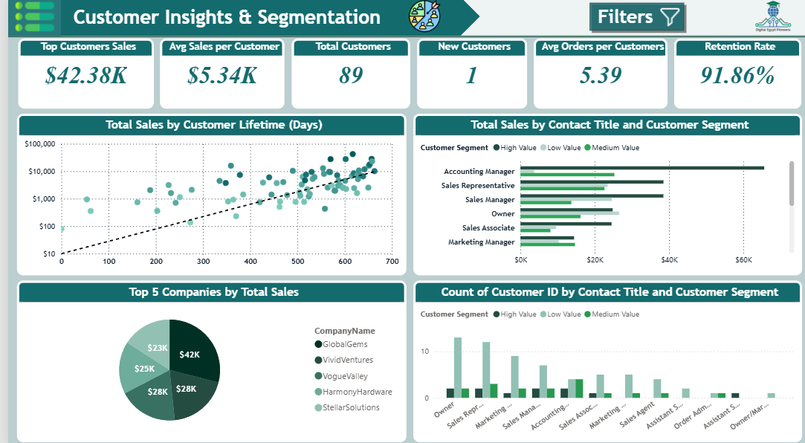

1. Key Metrics Overview
- Top Customer Sales: $42.38K
The top customer has contributed significantly to sales, indicating the presence of high-value customers.
- Average Sales per Customer: $5.34K
On average, each customer has spent $5.34K, suggesting a healthy average purchase per customer.
- Total Customers: 89
The business has a total of 89 customers. While the number of customers isn't very large, the sales figures suggest that the customer base is highly engaged or that there are significant high-value customers.
- New Customers: 1
Only one new customer has been acquired recently, indicating that acquiring new customers may be a key area for improvement.
- Average Orders per Customer: 5.39
On average, each customer has made just over 5 orders. This suggests that repeat customers contribute to a solid portion of sales.
- Retention Rate: 91.86%
The business has a high retention rate, which indicates strong customer loyalty and satisfaction.

2. Total Sales by Customer Lifetime (Days)
- Customer Lifetime vs. Total Sales:
The scatter plot shows a clear correlation between customer lifetime (in days) and total sales. As customer lifetime increases, total sales also increase, meaning that long-term customers tend to make larger or more frequent purchases.
Recommendation: Focus on nurturing long-term customer relationships through personalized services, loyalty programs, or targeted offers to maintain and increase this trend.

3. Total Sales by Contact Title and Customer Segment
- Accounting Managers and Sales Representatives are the highest contributors to total sales, with Accounting Managers significantly outperforming others in terms of sales.
Sales Managers and Owners also contribute noticeably.
Recommendation: Investigate why Accounting Managers and Sales Representatives have higher sales. Could it be related to their purchasing power, influence in decision-making, or business needs? Understanding this behavior can help replicate it for other customer segments.
- Low Value Customers (represented in light green) tend to make up a larger proportion of the sales in roles such as Sales Associate and Marketing Manager.
Recommendation: While it's good to have diversity in customer segments, consider creating strategies to move low-value customers into higher-value segments through better targeting, upselling, or loyalty programs.

4. Count of Customers by Contact Title and Customer Segment
- The Owner segment has the highest count of customers, followed by Sales Representatives and Sales Managers.
Recommendation: Given that Owners appear to represent a significant portion of your customer base, targeting them with higher-value offers could prove beneficial. Ensure that the product offerings align with the needs of decision-makers like Owners and Sales Managers.

5. Top 5 Companies by Total Sales
- The Top 5 Companies by Total Sales are:
  - GlobalGems: $42K
  - VividVentures: $28K
  - VogueValley: $28K
  - HarmonyHardware: $25K
  - StellarSolutions: $23K
Recommendation: GlobalGems is your top company by total sales, contributing a significant amount. It might be worth further analyzing this company to understand what specifically drives its high sales. Is there a particular product or service they purchase more frequently? Are there opportunities to cross-sell or upsell to them based on their purchasing behavior?

6. Key Insights & Recommendations
- Customer Lifetime Value (CLV):
  - There's a strong correlation between customer lifetime and total sales, meaning that long-term customers tend to generate more revenue. Focus on extending customer lifetime by improving retention strategies, offering loyalty programs, or delivering exceptional post-sale support.
- Target High-Value Segments:
  - The Accounting Manager and Sales Representative segments are your highest-value customer segments, so it would be beneficial to identify patterns in how these segments are interacting with your business. Consider offering them exclusive promotions, business-specific discounts, or bundled deals that appeal to their roles.
- Focus on Low-Value Customers:
  - You may want to identify strategies for converting low-value customers into medium-value or high-value customers. This could involve offering additional services or targeting them with product recommendations that increase their order volume. Upselling or cross-selling can be effective ways to increase the average order value.
- Increase New Customer Acquisition:
  - The business has only acquired 1 new customer. This highlights a potential area for growth, especially in expanding the customer base. Invest in customer acquisition strategies, such as referral programs, advertising campaigns, or partnerships that can attract new customers.
- Utilize Retention Rate for Marketing:
  - With a 91.86% retention rate, the business is retaining most of its customers. This is a strong asset. Consider using customer testimonials or case studies from your existing loyal customers to attract new clients or maintain engagement.
- Enhance Sales from Owners:
  - Since Owners are a high-count segment, you could benefit from targeting this group with tailored offers. Explore exclusive product ranges, loyalty programs, or B2B incentives that are designed for owners who may have larger buying power.
- Analyze Top Companies for Growth:
  - GlobalGems is your highest-grossing customer. Conduct a deeper analysis into their purchasing behavior to see if there are opportunities for upselling or long-term contracts. They may be a good candidate for partnership or exclusive deals, given their high volume of purchases.
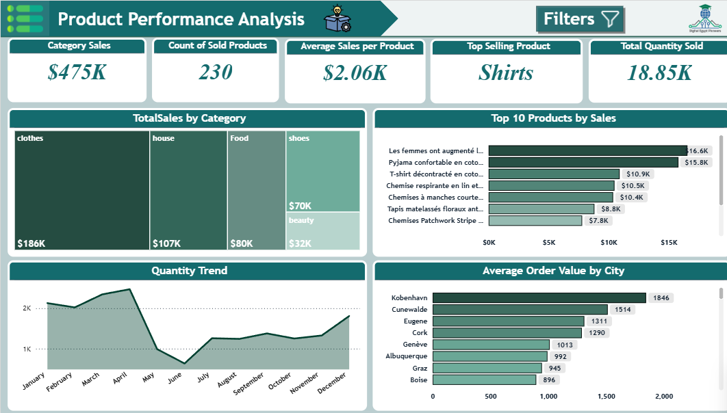

1. Overall Category Sales and Performance
- Total Sales: $475K
- Number of Sold Products: 230
- Average Sales per Product: $2.06K
- Top Selling Product: Shirts
- Total Quantity Sold: 18.85K
Insights:
- The average sales per product being $2.06K indicates good Selling as WE have lots of products
- Shirts are identified as the top-selling product, which might reflect strong market demand or a focused marketing strategy.
- With a total sales value of $475K, this indicates a significant volume of business in the reviewed period.
Recommendation:
- Given the strong sales performance of shirts, continue marketing efforts around these items, potentially exploring product diversification within the shirt category (e.g., different styles, materials, or seasonal offerings).
- Investigate the possibility of expanding the offerings within categories like shoes and beauty, which have comparatively lower sales, to balance the product mix.

2. Sales by Category
- Clothes: $186K
- House: $107K
- Food: $80K
- Shoes: $70K
- Beauty: $32K
Insights:
- The clothes category is by far the largest revenue driver with $186K in sales, making up almost 40% of total sales.
- The house and food categories show moderate sales, with $107K and $80K, respectively.
- Beauty and shoes categories are underperforming compared to others, with $32K and $70K in sales.
Recommendation:
- Clothes have proven to be the most lucrative category, and efforts should be made to expand the clothing line by offering more variety or seasonal options.
- For the beauty and shoes categories, it's important to explore market research to understand the reasons for low sales and decide whether to improve these products, phase them out, or re-strategize the marketing approach.
- Consider running promotions or campaigns for categories like beauty or shoes to boost consumer interest and engagement.

3. Top 10 Products by Sales
- The top 10 products have been highlighted, with the highest-selling product being "Les femmes ont augmenté "with $16.6K in sales.
Insights:
- The top 3 products are all from fashion-related categories (pajamas, T-shirts, and shirts). This aligns with the earlier finding that clothes are the highest-performing category.
- The products range in sales from $7.8K to $16.6K, suggesting a strong demand for specific items.
Recommendation:
- Given the high sales of these products, consider repeating or promoting similar products with similar features, materials, or themes.
- Analyze customer reviews and feedback to identify any common traits or features that make these products particularly attractive, then consider extending those qualities to new product lines.

4. Quantity Trend
- The trend shows that sales are highest in the Winter months (January to April as April the highest of all hear) with peaks over 2,000 units sold.
Insights:
- There is a clear seasonal fluctuation in product sales, with a notable drop after the mid-year peak, followed by another uptick toward the end of the year.
- The low point in sales happens between may to June, suggesting that certain months may require additional marketing support or promotions to maintain steady sales.
Recommendation:
- Adjust marketing strategies based on the seasonality of product sales. For example, increase marketing during the lower-performing months (May to June) to bridge the sales gap.
- Consider launching promotions or exclusive products during months with lower sales to maintain consumer interest and sustain year-round growth.

5. Average Order Value by City
- The top cities by average order value are:
  - København: 1846
  - Cunewalde: 1514
  - Eugene: 1311
  - Cork: 1290
  - Genève: 1013
  - Albuquerque: 992
  - Graz: 945
  - Boise: 896
Insights:
- København has the highest average order value, suggesting either a higher-income demographic or a concentrated target market that is willing to spend more.
- Other cities, like Cunewalde, Eugene, and Cork, also show strong average order values, indicating valuable customer bases in these areas.
Recommendation:
- Target marketing can be done more aggressively in cities like København, Cunewalde, and Eugene since these cities show the highest average order value.
- Explore localized offers and promotions tailored to high-value cities.
- Investigate cities with lower order values (e.g., Boise and Barcelona), and try to understand potential barriers to higher spend. A targeted campaign or tailored offerings in those areas might help improve average order values.

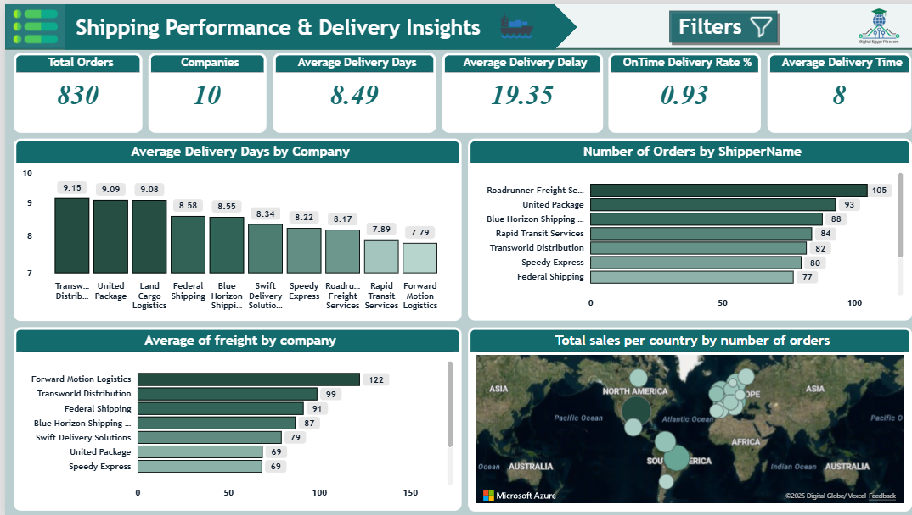
1. Overall Shipping Metrics
- Total Orders: 830
- Total Companies (Shippers): 10
- Average Delivery Days: 8.49
- Average Delivery Delay: 19.35
- On-Time Delivery Rate: 93%
- Average Delivery Time: 8 days
Insights:
- With 830 orders processed by 10 shipping companies, the volume of orders appears moderate. The average delivery time of 8.49 days is quite reasonable, suggesting efficient processing of orders overall.
- The on-time delivery rate of 93% indicates that most orders are delivered within the expected time frame, a strong performance metric.
- However, the average delivery delay of 19.35 days suggests there may be occasional delays in some orders, which could impact customer satisfaction.
Recommendation:
- Monitor and address delays: Investigate the sources of the average delivery delay to identify bottlenecks or companies causing these delays, especially if there are patterns with specific shippers.
- Consider improving communication around expected delivery times to customers, especially if delays are inevitable, to manage customer expectations.
- Strengthen partnerships with the top-performing companies to ensure even higher on-time delivery rates.

2. Average Delivery Days by Company
- The shipping companies are ranked as follows by their average delivery days:
  - Transworld Distribution: 9.15 days
  - United Package: 9.09 days
  - Land Cargo Logistics: 9.08 days
  - Federal Shipping: 8.58 days
  - Blue Horizon Shipping: 8.55 days
  - Swift Delivery Solutions: 8.34 days
  - Speedy Express: 8.22 days
  - Roadrunner Freight Services: 8.17 days
  - Rapid Transit Services: 7.89 days
  - Forward Motion Logistics: 7.79 days
Insights:
- The fastest delivery times are by Forward Motion Logistics and Rapid Transit Services, both averaging around 7.79 to 7.89 days.
- The slowest delivery times are from Transworld Distribution, United Package, and Land Cargo Logistics, all with an average delivery time of 9+ days.
Recommendation:
- Collaborate with slower delivery companies to identify reasons for delays and explore process improvements.
- Prioritize top performers like Forward Motion Logistics and Rapid Transit Services for faster or priority shipments, especially when time is of the essence.
- Regularly review performance data to ensure slow-performing companies are meeting their delivery timelines or are phased out if improvement is not achieved.

3. Average Freight Cost by Company
- The freight costs by company are as follows:
  - Forward Motion Logistics: $122
  - Transworld Distribution: $99
  - Federal Shipping: $91
  - Blue Horizon Shipping: $87
  - Swift Delivery Solutions: $79
  - Speedy Express: $69
  - United Package: $69
Insights:
- Forward Motion Logistics has the highest freight cost, which may be due to specialized or expedited services.
- Speedy Express and United Package offer the most cost-efficient shipping options at $69 per freight.
Recommendation:
- cost vs. speed trade-offs: the highest-cost companies (like Forward Motion Logistics) provide the necessary value, i.e., faster delivery times justifying the higher cost.
- Consider cost-effective solutions: Explore using Speedy Express and United Package for less urgent shipments to optimize overall shipping cost.
- Negotiate rates with high-cost shippers to reduce freight costs, especially if there are opportunities for volume discounts.

4. Number of Orders by Shipper
- The number of orders handled by each shipper:
  - Roadrunner Freight Services: 105 orders
  - United Package: 93 orders
  - Blue Horizon Shipping: 88 orders
  - Rapid Transit Services: 84 orders
  - Transworld Distribution: 82 orders
  - Speedy Express: 80 orders
  - Federal Shipping: 77 orders
Insights:
- Roadrunner Freight Services has the largest number of orders, which indicates they may be the most relied-upon service for fulfilling customer orders.
- Federal Shipping and Swift Delivery Solutions handle fewer orders compared to others, which may indicate limited usage or specialization.
Recommendation:
- Increase usage of high-volume shippers like Roadrunner Freight Services to leverage economies of scale and ensure consistent order fulfillment.
- Investigate whether Federal Shipping and Swift Delivery Solutions should be used more or whether there are specific reasons for their limited involvement (e.g., geographical coverage, reliability).

5. Total Sales Per Country by Number of Orders
- The map shows the sales distribution per country based on the number of orders.
Insights:
- The map visualization helps identify countries with the highest volume of orders and sales.
- Countries in North America, Europe, South America appear to have all order volume, while Africa and Australia Asia have NO orders.
Recommendation:
- Focus on high-performing regions: For example, regions with high order volumes (North America and Europe) should be prioritized for further investment in logistics, advertising, and partnerships.
- Increase marketing in low-order regions: Explore expanding presence or improving shipping options in areas like Africa and Asia to boost order volume.
- Localized shipping strategies: Consider tailoring shipping solutions based on regional demand patterns to reduce delivery times and costs.
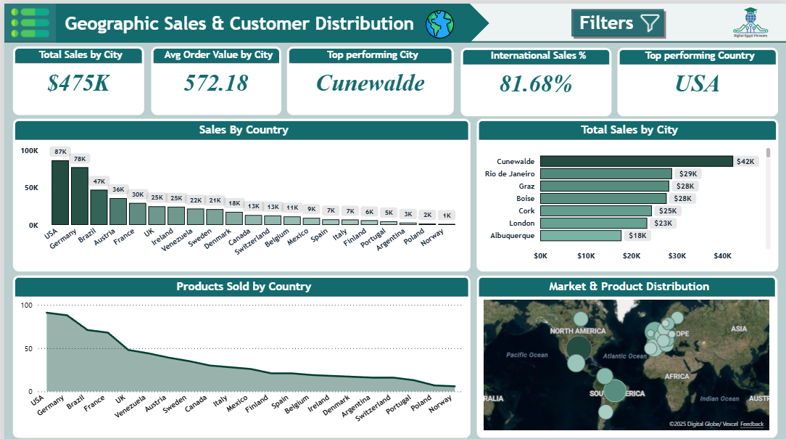

Top-Level Summary Metrics

1. Average Order Value by City: 572.18
A moderate AOV suggests customers are making purchases of decent value, but there is room to push higher basket sizes.

2. Top-Performing City: Cunewalde → $42K
This city leads all others in revenue generation.

3. International Sales %: 81.68%
A very high figure—this means the majority of sales come from countries outside the company's base country.

4. Top-Performing Country: USA → $87K
The U.S. leads by a significant margin in total national revenue.

Detailed Insights

1. Sales by Country — Market Strength & Distribution

Top Countries by Revenue:
Country | Sales
USA | $87K
Germany | $78K
Brazil | $47K
Austria | $36K
France | $30K
UK | $25K
Ireland | $25K

Insights:
- USA dominates with the highest sales, showing it is your strongest and most reliable market.
- Germany is close behind, indicating strong European presence.
- Brazil as #3 highlights opportunity in the South American market.
- European footprint (Austria, France, UK, Ireland, Italy, Spain, Belgium) is strong and diversified.
- Lower-tier countries (Poland, Norway, Argentina, Portugal) represent growth potential.

Strategic Interpretation:
- Your demand is globally diversified, reducing dependency risk.
- Europe + USA = major combined revenue (>60%) → focus region for expansion and operational optimization.

2.Total Sales by City — Micro-Market Leaders

Top Cities:
City | Sales
Cunewalde | $42K
Rio de Janeiro | $29K
Graz | $28K
Boise | $28K
Cork | $25K
London | $23K
Albuquerque | $18K

Insights:
- Cunewalde is a significant outlier, outperforming all cities by a large margin.
- Rio de Janeiro, Graz, and Boise represent high-spending pockets across continents:
  - South America
  - Europe
  - North America
- Lower-performers like Albuquerque still show healthy contributions.

Strategic Interpretation:
- City-level marketing segmentation is working—local pockets of demand are strong.
- Cunewalde may represent:
  - A loyalty hotspot
  - Specific demographic alignment
  - Successful marketing campaign
Further investigation recommended.

3.Products Sold by Country — Market Penetration Levels

Insights:
- The same countries with high sales also show high product unit counts (USA, Germany, Brazil), meaning:
  - Higher number of orders
  - Higher customer base
  - Strong brand presence
- Countries like Poland, Norway, Portugal show low unit sales, suggesting:
  - Weak penetration
  - Lack of brand awareness
  - High logistic costs
  - Cultural mismatch

Strategic Interpretation:
- Most revenue is driven by both volume + value, not just high-value orders.
- Low-performing countries could improve through:
  - localized ad campaigns
  - partnerships with regional distributors
  - adjusted shipping pricing

4.Market & Product Distribution — Global Footprint

Insights:
- The map visualization shows:
  - High density in North America, Europe, Brazil.
  - NO density in Africa.
- This indicates strong global reach but uneven distribution.

Strategic Interpretation:
- Opportunities exist to stabilize and expand presence in:
  - Asia (large consumer markets)
  - Africa (emerging markets)
  - Australia (high purchasing power but underpenetrated)

Key Insights Summary

Strengths
- USA and Europe are major revenue drivers.
- Cunewalde and Rio de Janeiro show exceptional city-level performance.
- High international sales share (81.68%) reveals strong global demand.
- Deep market penetration in multiple high-value countries.

Weaknesses
- Some countries have very low sales—suggests gaps in marketing or distribution.
- Heavy dependency on a few strong markets (USA, Germany).
- AOV could be increased.

🎯 Opportunities
- Expand into Asia-Pacific and high-population markets.
- Grow low-performing countries through localized digital marketing.
- Introduce new product tiers to increase AOV.

Threats
- Reliance on international sales makes company vulnerable to:
  - currency volatility
  - international shipping delays
  - geopolitical issues

Comprehensive Recommendations

1. Market Expansion Strategy

Target high-potential but underpenetrated regions:
- Asia (India, Japan, South Korea): Fast-growing online shopping markets.
- Australia: High-income customer base.
- Africa (South Africa, Egypt): Emerging ecommerce markets.

Action Steps:
- Regional-language landing pages
- Local influencers & micro-influencers
- Geo-targeted Facebook/Instagram/TikTok ads

2. Strengthen Strong Markets (USA & EU)

Recommendations:
- Retargeting campaigns for repeat customers
- Loyalty programs
- Free shipping thresholds to increase AOV
- City-specific campaigns in Cunewalde, Rio, and Graz

3.Boost Low-Performing Countries
Countries like Norway, Poland, Argentina, Portugal
need specific actions:

Strategies:
- Research pricing sensitivity
- Offer reduced shipping costs
- Partner with local delivery providers
- Create country-specific promo campaigns

4. Increase Average Order Value (AOV)

Tactics:
- Bundles and product kits
- Bulk purchase discounts
- Cross-selling on checkout (e.g., “Complete the Look”)
- Limited-time offers to capture impulse buys
Goal: Increase AOV from 572 → 650+

5. Deep-Dive into Top Cities

Cunewalde:
- Explore:
  - Customer demographics
  - Ad performance
  - Product preferences
Replicate targeting strategies in similar cities.

Rio & Graz:
- High revenue suggests strong interest—expand SKUs that sell best in these regions.

6.Optimize Shipping & International Delivery
Given high international sales (81.68%), invest in:
- Regional distribution centers
- Faster local partners
- Optimized pricing for shipping-heavy countries

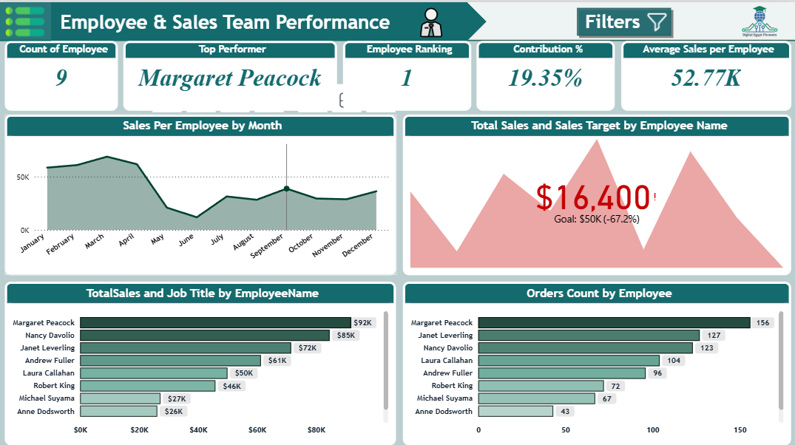

1. Overview of Sales Data
- Total Number of Employees: 9
- Top Performer: Margaret Peacock (Ranked 1st)
- Contribution Percentage of Top Performer: 19.35%
- Average Sales per Employee: $52.77K
- Sales Target: $50K (Current sales achieved: $16,400, which is 67.2% below the target)

2. Sales Performance Insights
- Sales per Employee by Month:
  - Can be used for each employee.
- Total Sales by Employee:
  - Top Performer: Margaret Peacock with total sales of $92K.
  - Other strong performers include Nancy Davolio ($85K) and Janet Leverling ($72K), with total sales significantly higher than others.
  - Some employees (e.g., Michael Suyama and Anne Dodsworth) have lower total sales, which could indicate areas for improvement.
- Orders Count:
  - Margaret Peacock leads with 156 orders, followed by Janet Leverling with 127 orders and Nancy Davolio with 123 orders.
  - The correlation between order count and total sales shows that higher order volumes contribute significantly to overall sales performance. Hence, there is potential for boosting performance by focusing on increasing order numbers.

3. Sales Target and Achievement
- Sales Target: The target is set at $50K, and the total sales currently stand at $16,400 (which is just about 33% of the target).
- This indicates that the sales team is significantly underperforming relative to the target.

4. Employee Contribution
- Top Contributor: Margaret Peacock, contributing almost 19.35% of the total sales, stands out as the highest-performing employee.
- Recommendations: Recognizing top performers like Margaret and using their strategies or approach as case studies could be an opportunity for growth. Further incentives for top performers might help encourage others to follow similar strategies.

5. Employee Ranking & Performance Distribution
- Employee Rankings: The ranking shows a mix of employees performing at various levels. Some, such as Margaret and Janet, are outpacing others, while some employees like Robert King and Andrew Fuller are mid-level performers.
- Low Performers: Employees such as Michael Suyama and Anne Dodsworth are underperforming with lower total sales and fewer orders.
- Recommendations:
  - Targeted Training & Support: Employees in the lower tier should receive additional training, mentorship, or performance reviews to identify challenges. Support could include focused sales strategies or tackling specific barriers.
  - Incentives: More incentives for high sales volume or new customer acquisition might drive more engagement among the underperformers.

6. Key Performance Areas for Focus
- Underperforming Periods: A closer look at the months when sales dropped, can uncover reasons. Did these months coincide with a product launch failure, market saturation, or reduced customer demand?
- Orders and Conversion Rates: More orders tend to translate to higher sales. Thus, improving conversion rates or sales efficiency is essential. It might be worth analyzing the order-to-sale ratio.
- Sales Strategy Refinement: Top performers like Margaret Peacock and Nancy Davolio may have effective strategies that could be scaled or shared across the team. Understanding the methods used by top sellers could be key in elevating the overall team’s performance.

7. Actionable Recommendations
- Review Sales Performance per Month: Analyze why certain months show sales slumps. It might be related to external factors, such as holidays or seasonal slowdowns.
- Implement Cross-Training Programs: Use top performers as mentors to help other employees. Sharing successful strategies, such as effective closing techniques or product upselling, could help elevate the entire team's performance.
- Increase Focus on Order Volume: Employees with higher order counts generally perform better in sales. Strategies should be aimed at driving more customer orders, whether through promotions, loyalty programs, or incentivized targets.
- Targeted Incentive Programs: Consider bonus structures or rewards for achieving specific goals like increasing order numbers or surpassing sales targets.
- Address Low Performers: Specific attention should be given to employees who are underperforming, focusing on performance reviews, setting smaller incremental goals, and offering personal coaching.
- Customer Relationship Management: Strengthen customer relationships to boost repeat business and encourage upselling. Developing stronger customer retention strategies can help in achieving consistent sales results.
- Sales Campaigns: Boost team efforts during low-performing months through aggressive sales campaigns or discounts to revive customer interest.
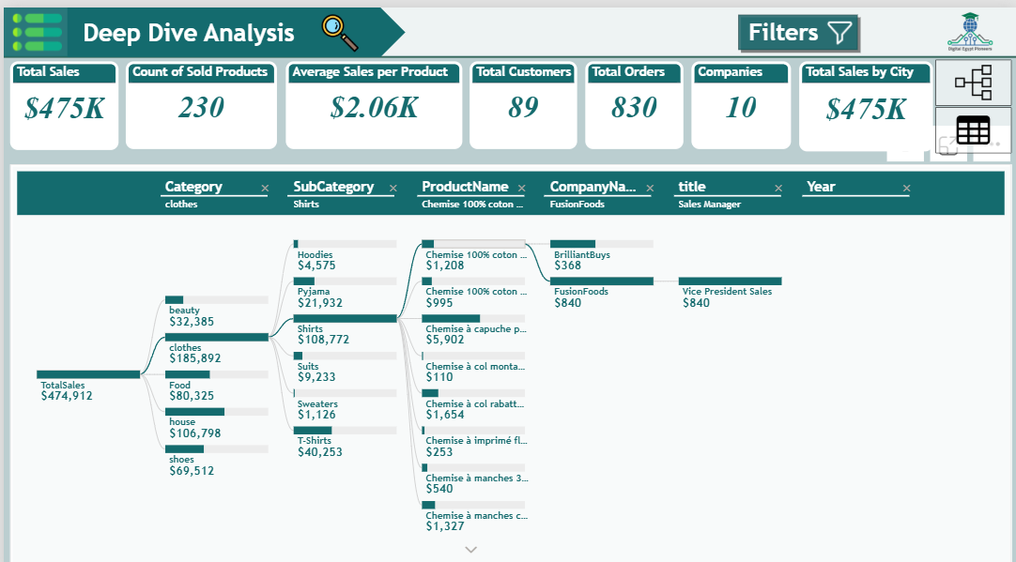

1. General Overview
- Total Sales: $475K
- Total Products Sold: 230 products
- Average Sales per Product: $2.06K
- Total Customers: 89
- Total Orders: 830
- Number of Companies: 10
This data gives an insight into the sales performance across multiple categories, subcategories, and companies, which helps in identifying strengths and areas of improvement.

2. Breakdown by Categories
The sales are broken down by category, with Clothes being the leading category. Below is the breakdown:

Sales by Category:
- Clothes: $185,892 (Highest sales)
- Food: $80,325
- Beauty: $32,385
- Shoes: $69,512
- House: $106,798

Recommendations:
- Focus on Clothes: Since the Clothes category accounts for the highest sales, continuing to optimize this category with new products or marketing could yield higher sales.
- Increase Investment in Food and Shoes: Food and shoes, though not as high as clothes, show promising numbers. Strategic promotions, bundling, or offering discounts could potentially drive sales in these areas.

3. Subcategory Sales (Under Clothes)
The subcategories within Clothes have distinct sales levels:
- Shirts: $108,772 (Dominates the Clothes category)
- T-Shirts: $40,253
- Suits: $9,233
- Sweaters: $1,126
- Hoodies: $4,575
- Pyjama: $21,932

Insights:
- Shirts as a Top Performer: The Shirts subcategory is by far the top seller in the Clothes category, suggesting that this should be a primary focus. Expanding the variety or styles of shirts could drive further growth.
- T-Shirts and Pyjamas: Both T-shirts and Pyjamas are performing well. Consider launching new seasonal designs or collections to tap into more customer segments.

Recommendations:
- Focus on Expanding Shirts Line: More products, designs, or exclusive collections in the shirts segment could capitalize on its success.
- Improve Low-Performing Subcategories: Sweaters, Hoodies, and Suits are underperforming. Promotions, improved quality, or market research into customer preferences could help boost sales.

4. Product-Level Analysis
This breakdown reveals the best and worst performing individual products.
- Top Seller: Chemise 100% coton – $5,902 (One of the high-ticket items in the Shirts category)
- Other notable products:
  - Chemise à col montagne – $1,654
  - Chemise 100% coton (other variants) – $995 and $1,208
  - T-shirt and Pyjama lines – Various price points below $1,000

Recommendations:
- Promote High-Ticket Items: The products with high sales (e.g., Chemise 100% coton) should be featured more prominently in marketing campaigns.
- Monitor and Adjust Pricing: Evaluate the price points of lower-performing products (such as some T-shirts or Hoodies) to see if adjusting pricing or improving features could boost sales.

Insights:
- FusionFoods has strong sales performance compared to other companies. It may benefit from enhanced visibility in sales strategies, either by cross-selling with other categories or focusing more efforts on this company's products.

Recommendations:
- Focus on Strengthening Relationships with FusionFoods: Given their higher sales, it’s advisable to increase collaboration or co-marketing efforts with FusionFoods to push their products even further.

7. Insights on Sales Across Cities
The overall total sales of $475K are distributed across 10 cities. Specific city-level sales data could further help identify areas for targeted campaigns.

Recommendations:
- Target Low-Performing Cities: Investigate which cities are underperforming in sales. Consider targeted promotions, localized marketing strategies, or online campaigns to boost sales in these areas.
- Replicate Success in High-Performing Cities: For cities that are performing well, replicate the successful strategies in other regions.

Conclusion & Strategic Recommendations:
- Focus on Top Categories: Clothes, specifically shirts, are the top-performing category. Investing in expanding and marketing these products will likely drive higher sales.
- Product Differentiation and Promotions: Consider introducing new designs, offers, and bundles for top-performing items and review low-performing categories to improve their appeal.
- Strengthen Company Partnerships: Collaborate further with high-performing companies like FusionFoods to increase visibility and sales.
- Leadership and Training: Use the strategies of successful sales leaders to train and motivate the wider sales team.
- Geographic Sales Optimization: Examine sales performance across cities to identify underperforming regions and launch tailored marketing efforts for those locations.
- Pricing and Product Improvements: Monitor pricing and ensure that product offerings match customer needs and expectations.
- Conclusion
The Alex Agency Analytics Power BI project has successfully transformed raw transactional data into a centralized, dynamic, and actionable intelligence platform. By implementing a robust Star Schema data model, the foundation has been laid for high-performance analytics, enabling stakeholders across the organization to make faster, more informed decisions.
Key strategic insights reveal a business with strong global demand (82% international sales) and impressive growth (60% YoY), yet one that faces challenges with seasonal volatility and untapped market potential. Critically, the project has identified clear paths to revenue optimization: by capitalizing on seasonal peaks (Q1), boosting weekend sales, nurturing high-lifetime-value customers, and expanding presence in high-potential, underpenetrated markets like Asia-Pacific.
The interactive dashboards empower teams to move beyond hindsight reporting to foresight and action—whether it's the marketing team designing city-specific campaigns, sales managers coaching underperforming employees, or logistics optimizing carrier performance. This project is more than a reporting tool; it is a strategic asset that bridges the gap between data and decision-making, directly supporting the company's goals for growth, efficiency, and a truly data-driven culture. Future enhancements, such as integrating predictive analytics, will further solidify this competitive advantage.

THANKS FOR YOUR TIME
Alex Agency Analytics Team

